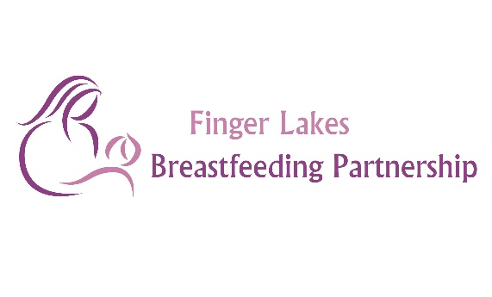
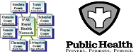
Finger Lakes Breastfeeding Partnership
Meeting Minutes for February 13th, 2016 at 3:00pm-4:30 pm
Meeting Held via Zoom due to Weather

Attendees:

Via Zoom: Christy Richards (Ontario County Public Health (PH)), Hillary Anderson (S2AY Rural Health Network), Susan Sheets (Wayne County PH), Mylessia Candie (Livingston County PH), Maureen Weidman (La Leche League), Pat Tremaine (Chemung County PH), Kellie Lockwood, Angela Druker (Yates County PH), Sara Schrader (Yates County PH), Megan Peters (Seneca County PH), Jo-Anne Taylor (Steuben County PH), Lorelei Wagner (Steuben County PH), Hannah Childs (SPCC WIC), Barb McGuffie (Yates Cornell Cooperative Extension), Darcy Dreyer (March of Dimes), Janel Walker (Schuyler County PH)

Topic | Discussion | Action | Closed
1. Welcome and Approval of Minutes | The group reviewed the meeting minutes from the January meeting. No changes were noted to the minutes, all were in favor of accepting the minutes as presented. | Minutes Accepted | Yes
2. Grant Updates | Hillary shared that the Network has still not heard about the LIFT Grant. If awarded, this grant will provide significant funding for breastfeeding efforts. Efforts include CLC trainings, Baby Cafes, incentives, books, materials to support breastfeeding friendly certification of practices and daycare centers/homes, and staff time. Hillary will keep the group updated as soon as the Network hears about this grant.
3. Presentation – March of Dimes | Darcy from the March of Dimes (MOD) gave a presentation to the group. Christy will send out the PowerPoint to the group. The mission of the MOD is to improve the health of babies by preventing birth defects, premature birth, and infant mortality rate. The MOD carries out this mission through community services, advocacy, research, education, and support. The New York areas of focus for the MOD are birth spacing, group prenatal care, and increasing the use of progesterone shots (17p). With additional maternal, infant, child health measures being added to the Partnerships workplan for 2017, the Partnership looks forward to working more closely with the MOD to meet shared goals.
4. Baby Café Updates | Christy and Hillary shared that Lucia reached out regarding data not being submitted by the Cafes in our region. Susan shared that they have tried to send the data, but it doesn’t seem to go through. Janel shared the same information, all of the other Café representatives agreed. The group discussed the data that Baby Café requires to be collected. Several Café representatives felt that the data is not very useful and does not accurately represent the information we would like to know. The group talked about coordinating a call with Lucia to talk about these concerns. Hillary will reach out to Lucia about this. | Hillary to reach out to Lucia about scheduling a call | No
5. Mission/ Vision Review | The group discussed the mission and vision statements. The group talked about how the statements need to be culturally and linguistically appropriate. The group talked about removing the word optimal and adding for all families. The group talked about the different audiences we need to consider when finalizing the mission and vision. Christy will send the updated mission and vision. She is also updating the member list and will send that out. | Christy to send updated mission/ vision and member list | No
6 Group Sharing | Christy shared that she is investigating the possibility of holding the Baby and Me Tobacco Free Program at Child and Family Resources.  Megan shared that the new Baby Bistro in Seneca County had their first meeting on February 3rd.  Susan shared that they are looking at different locations for the Baby Café. They are going to try to hold Café meetings every Thursday to try to gain more attendance.  Pat shared that they are opening another Baby Bistro in Horseheads at the Family Resource Center. She also shared that Arnot is hosting a Community Baby Shower on March 18th.  Mylessia shared that Livingston County is not going to renew their Baby Café license, the staffing model does not work for their organization. They are changing their Baby Café to a parent led group model. She shared that they have at least 6-7 moms at every Café meeting, so they really needed to change their space and model to meet their needs. They have moved their location to the Dansville Public Library. She shared that they are having at least one CLC or Registered Nurse at each meeting, with an IBCLC on call.  Janel shared that they are still trying to gain more attendance at their Baby Café. She also expressed that the staffing model of Baby Café is difficult to accommodate. She shared a model that she heard of that is being used in the Catskills area, “Baby Nook”.
Next Meeting | The next meeting will be held on March 13th, 2017 at 3:00PM at Ontario County Public Health in the Public Health conference room.

Respectfully submitted by Hillary Anderson (S2AY) on March 7th, 2017.

